**PROJECT - ERP**

**Team:**

Ishan, Nikhar, Aishaan, Vidisha

**Project Abstract:**

This is an *Enterprise resource planning* site for a school in which teachers and students can carry out their day to day academic work.

Students can upload assignments, download resources, view marks, view profile and pay fees.

Teachers can view assignments, upload resources, enter marks, view profile and send class messages.

**UI:**

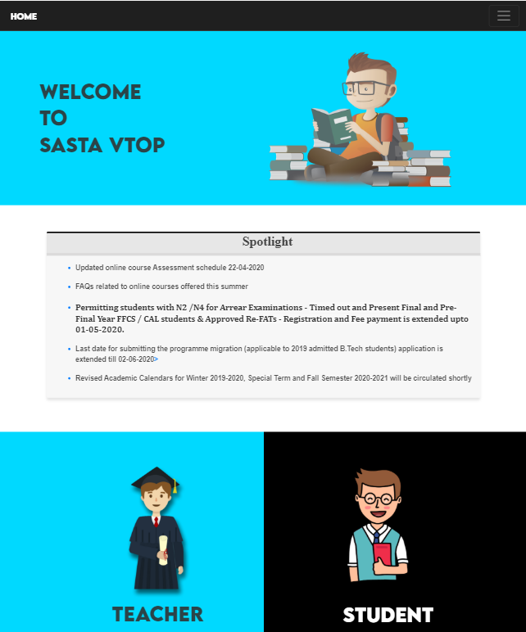

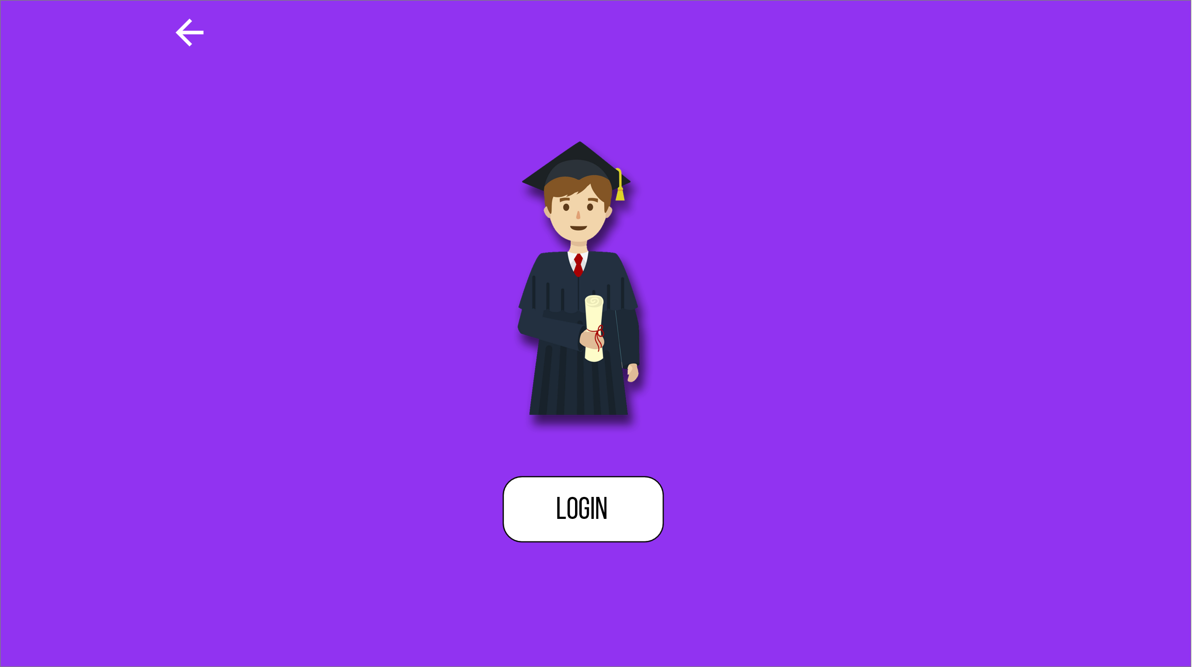

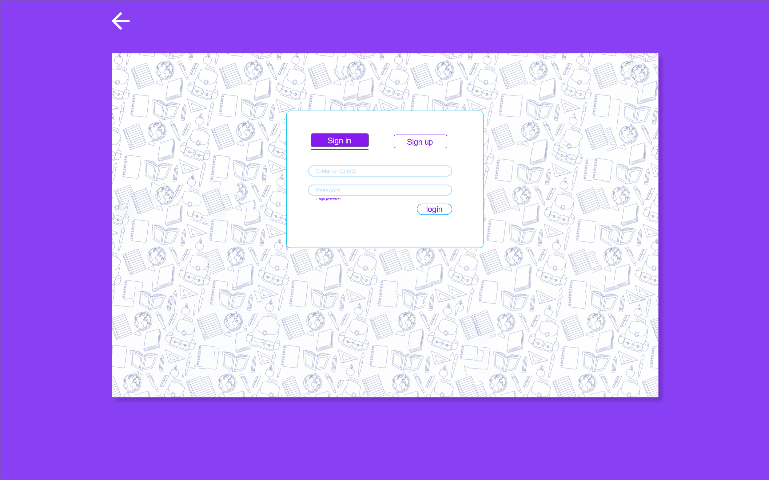

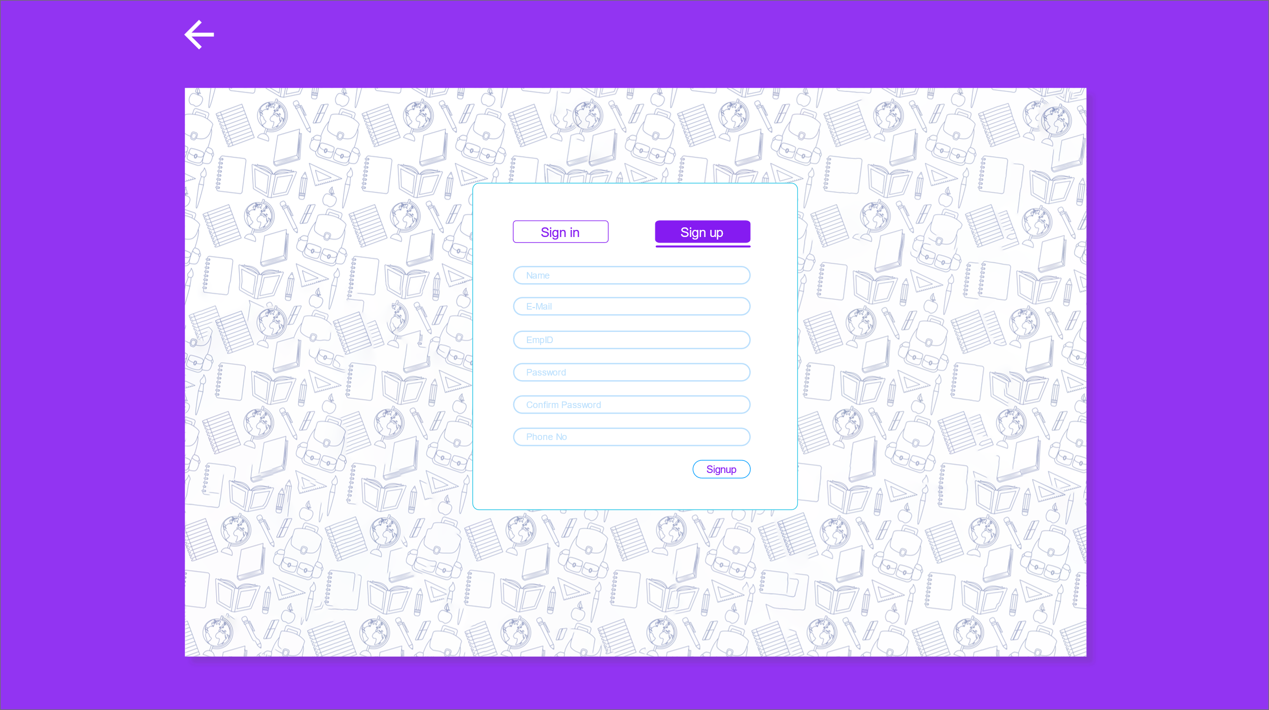

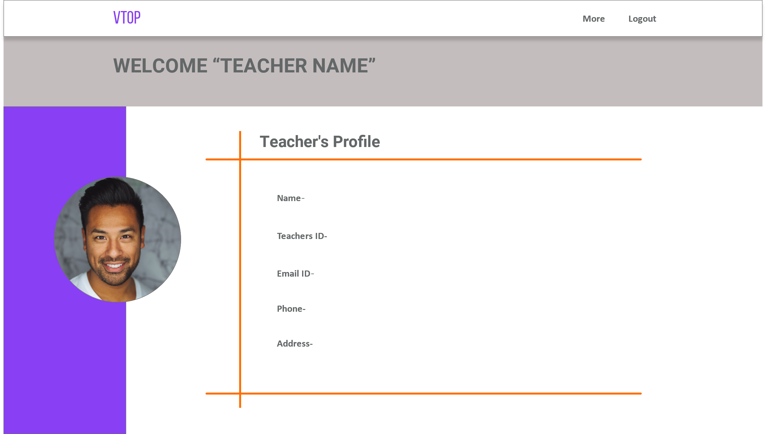

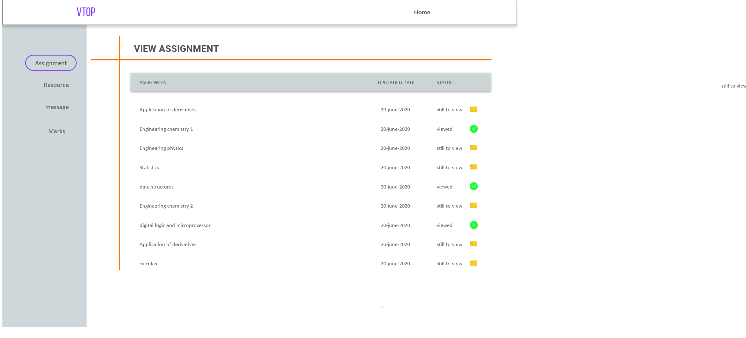

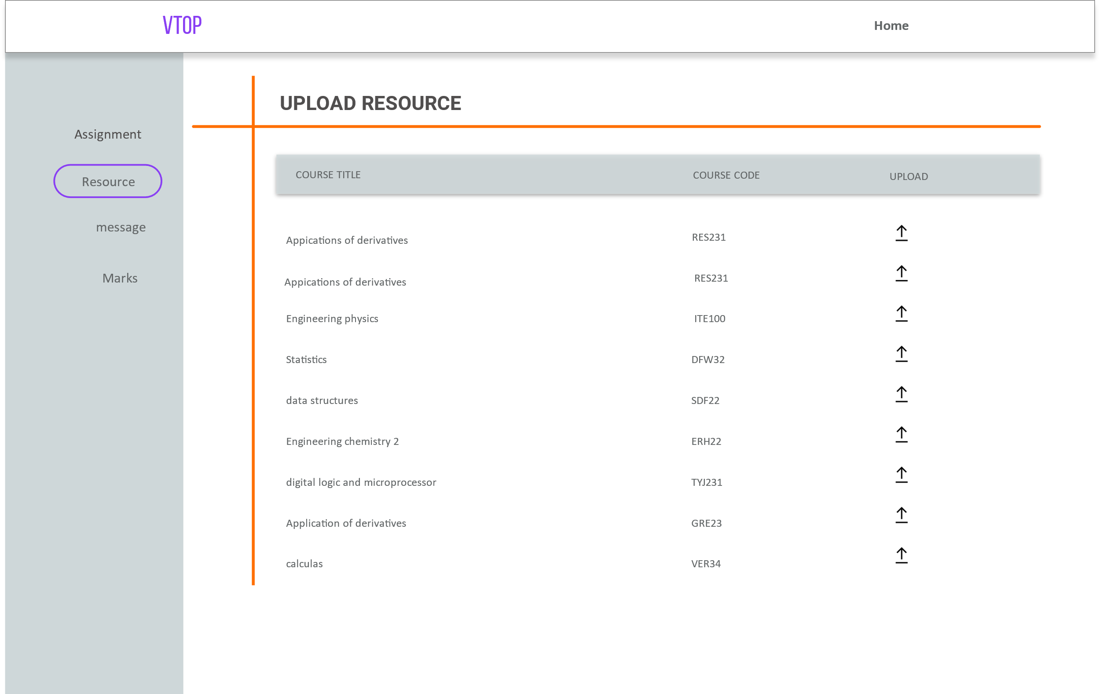

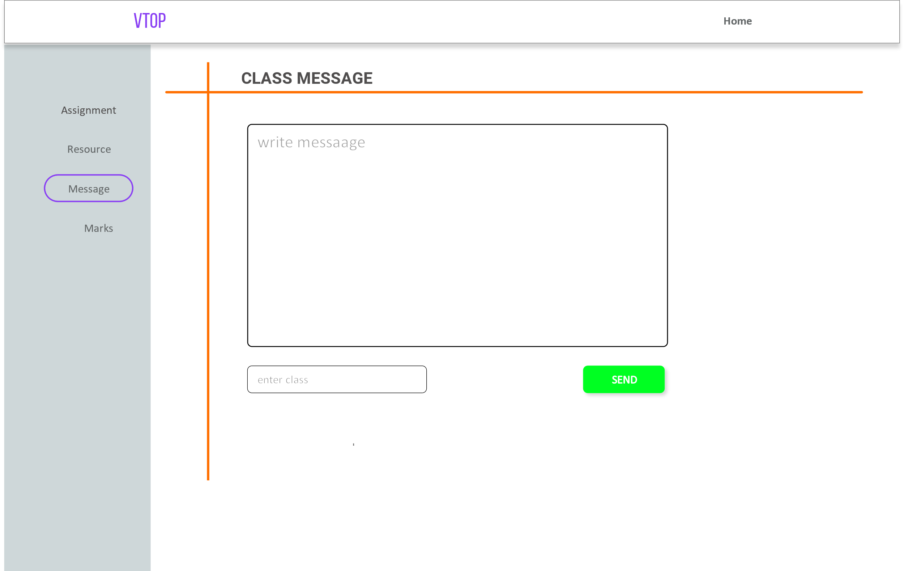

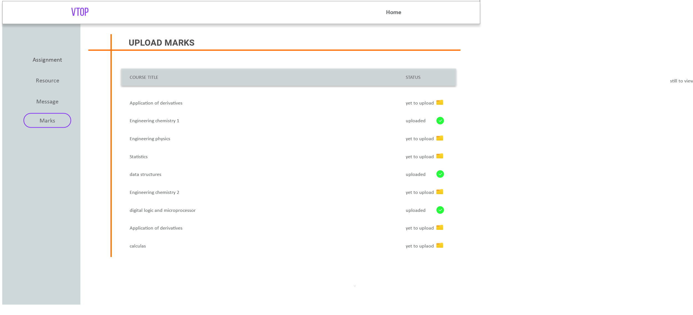

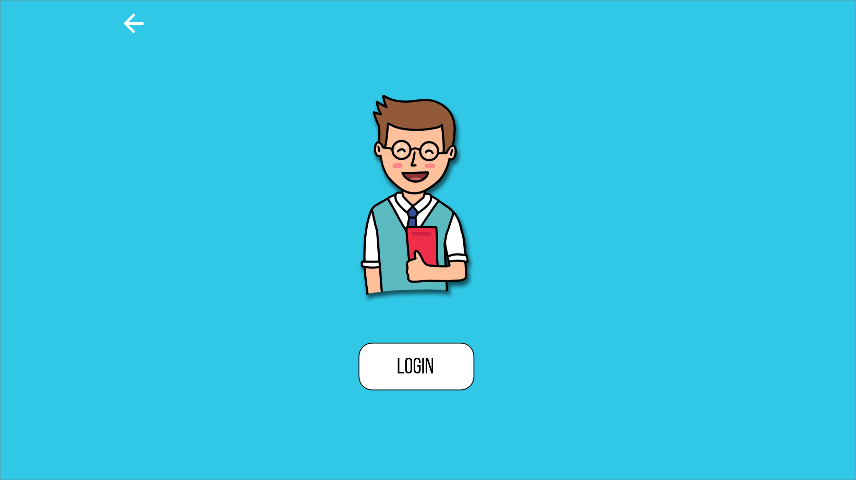

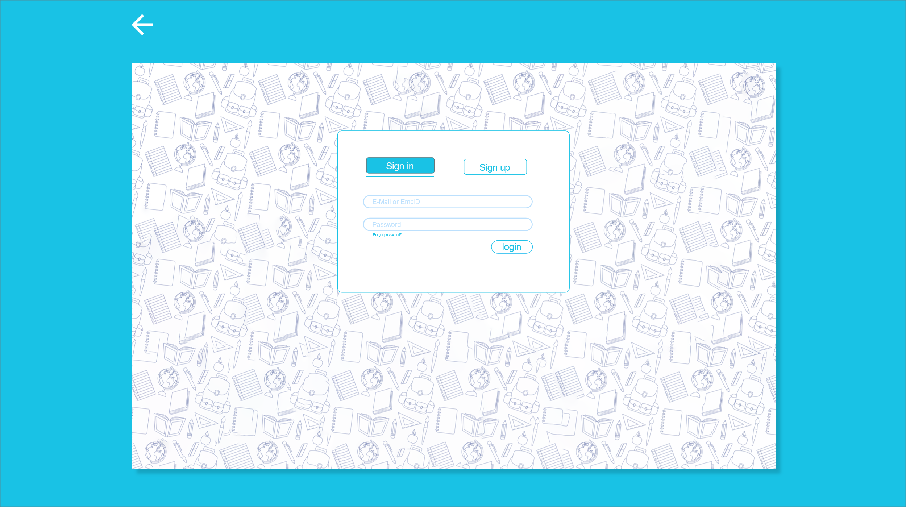

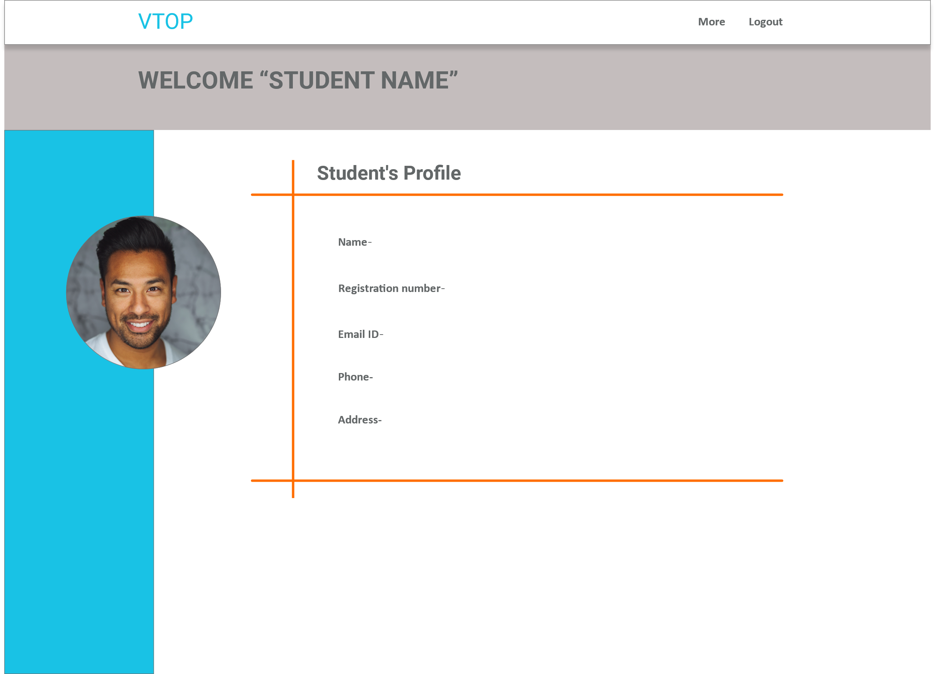

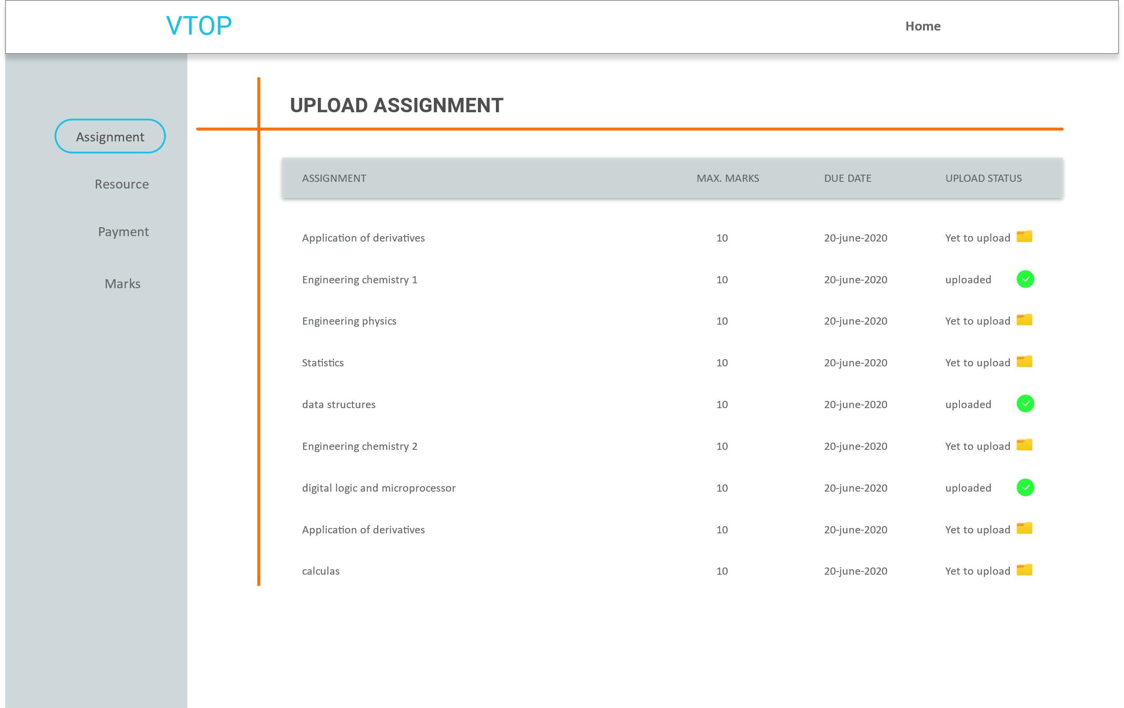

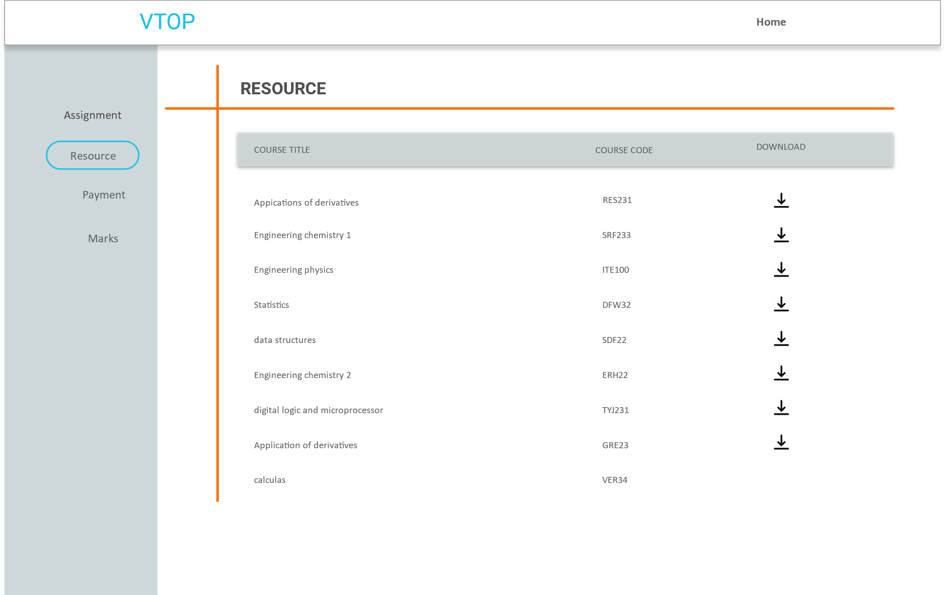

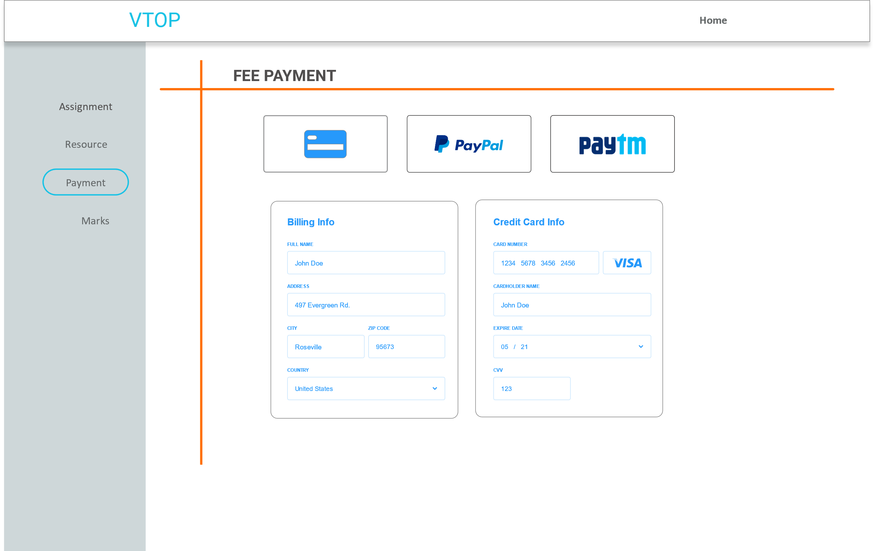

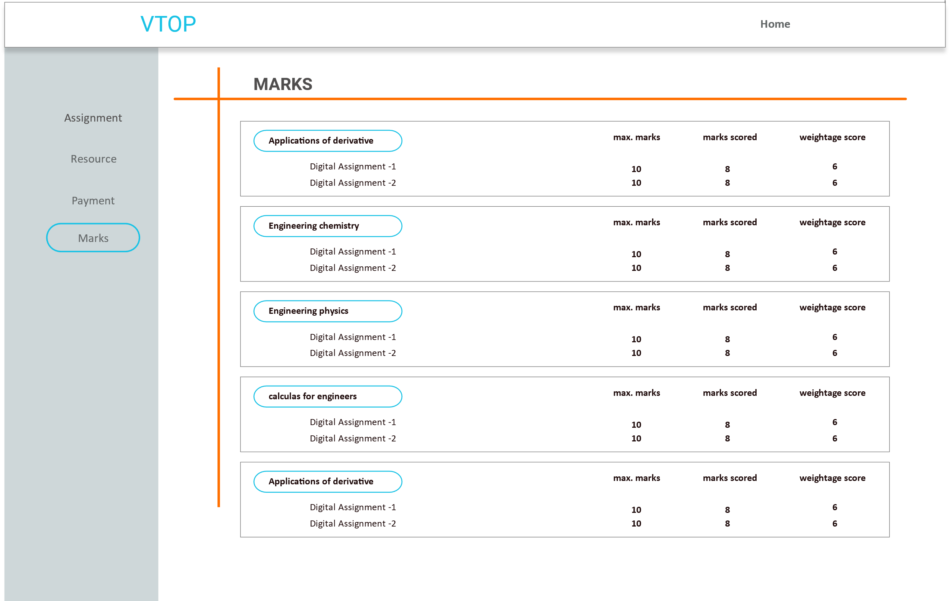

**Software and Technologies used:**

The frontend is created using languages HTML, CSS and JavaScript. Adobe XD was used to create the UI of the website. Visual Studio Code is the text editor used to create the website. The backend of the website would involve software like Mongo DB and Node JS.